Remote Learning Opportunities to Support Communication Skills
Websites that contain LOTS of speech/language therapy ideas for articulation, language, etc in one space: Speech Room News

Parent suggestions for working on your child’s speech and language skills:
How can my child work on his/her speech & language skills?

Articulation  For students of any age: Word/sentence/paragraph lists by sound  Games for younger students  Create word searches or crosswords from speech sounds word list:  abcya.com word search  abcya.com crossword puzzles  crossword puzzle creator junior (up to grade 3)  Free articulation apps:  - SmallTalk Phonemes  - Speech Therapy Articulation App  - Word Vault Essential  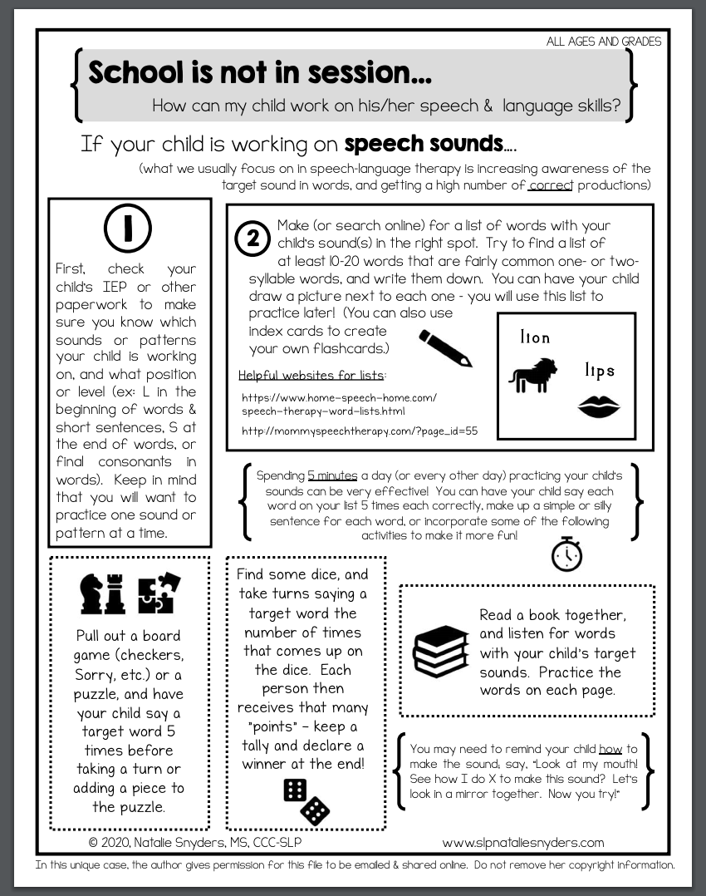 | Language  https://do2learn.com/SocialSkills/CommunicationSkills/index.htm  Grammar help  Following directions using recipes  Passages to read, ask and answer questions, etc  Activities to do each day of the month- March  Activities to do each day of the month-April  For middle school-age kids:  Multiple receptive/expressive lang. activities  Free language apps:  - Apps For Wh questions  - English-WH Question & Answer,  - Autism iHelp- Wh questions  - Question Therapy: Lite  - Let’s Name Things Fun Deck  - Inference Clues-Lite  - Pumpkin Sentences (for adjectives and/or sentence structure)  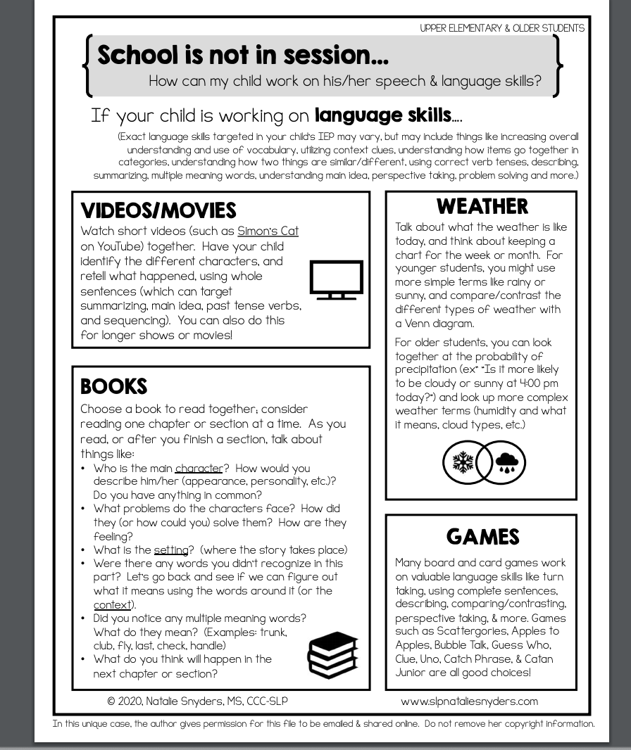
Fluency  TREATMENT MATERIALS linked handout copy  101 Things To Do - National Stuttering Association  The Stuttering Foundation  Resources for parents  Just for Kids-a special place for kids who stutter | AAC  Boardmaker boards/activities  Activities to do each day of the month- March (early communicator page)  Activities to do each day of the month-April (early communicator page)  “Lauren S. Enders, MA, CCC-SLP” (like her on FB - she has lots of great ideas AND you can follow her Pinterest boards)  AAC for Caregivers  Super Simple Songs  Core word boards from ThinkSmartBox that you can print from home  - Super Core 12  - Super Core 20  - Super Core 30  - Super Core 50  Caregivers of those using AAC  Talking Mats, AAC for social language  Using Proloquo2go to talk about COVID-19  AAC Calendar  Downloadable Communication Boards  Apps for Individuals with Complex Communication Needs
Audiobooks  Celebrities reading books  Audible stories for free  Authors read their storybooks  Bookflix, if you have a Schlow library card  https://www.storylineonline.net/  Audiobook Resources | General  Fun typing games  Yoga  GoNoodle  Virtual field trips  Information Sheets from Callscotland  Emergency Library of Digital Books  visual of how to wash your hands well!

Coronavirus social stories:
https://carolgraysocialstories.com/wp-content/uploads/2020/03/Pandemics-and-the-Coronavirus.pdf

https://www.teacherspayteachers.com/Product/COVID-19-Coronavirus-Social-Story-for-SpEd-or-Early-Elem-5323750

For basic AAC board users (can be printed or pulled up on a screen to target direct selections (pointing/touching pic), eye gaze to look at the answer choice, or other way to indicate a choice)
